Brandon Hobbs

CS-320

**Module 4 JUnit *Proof of Life***

***Original Code***

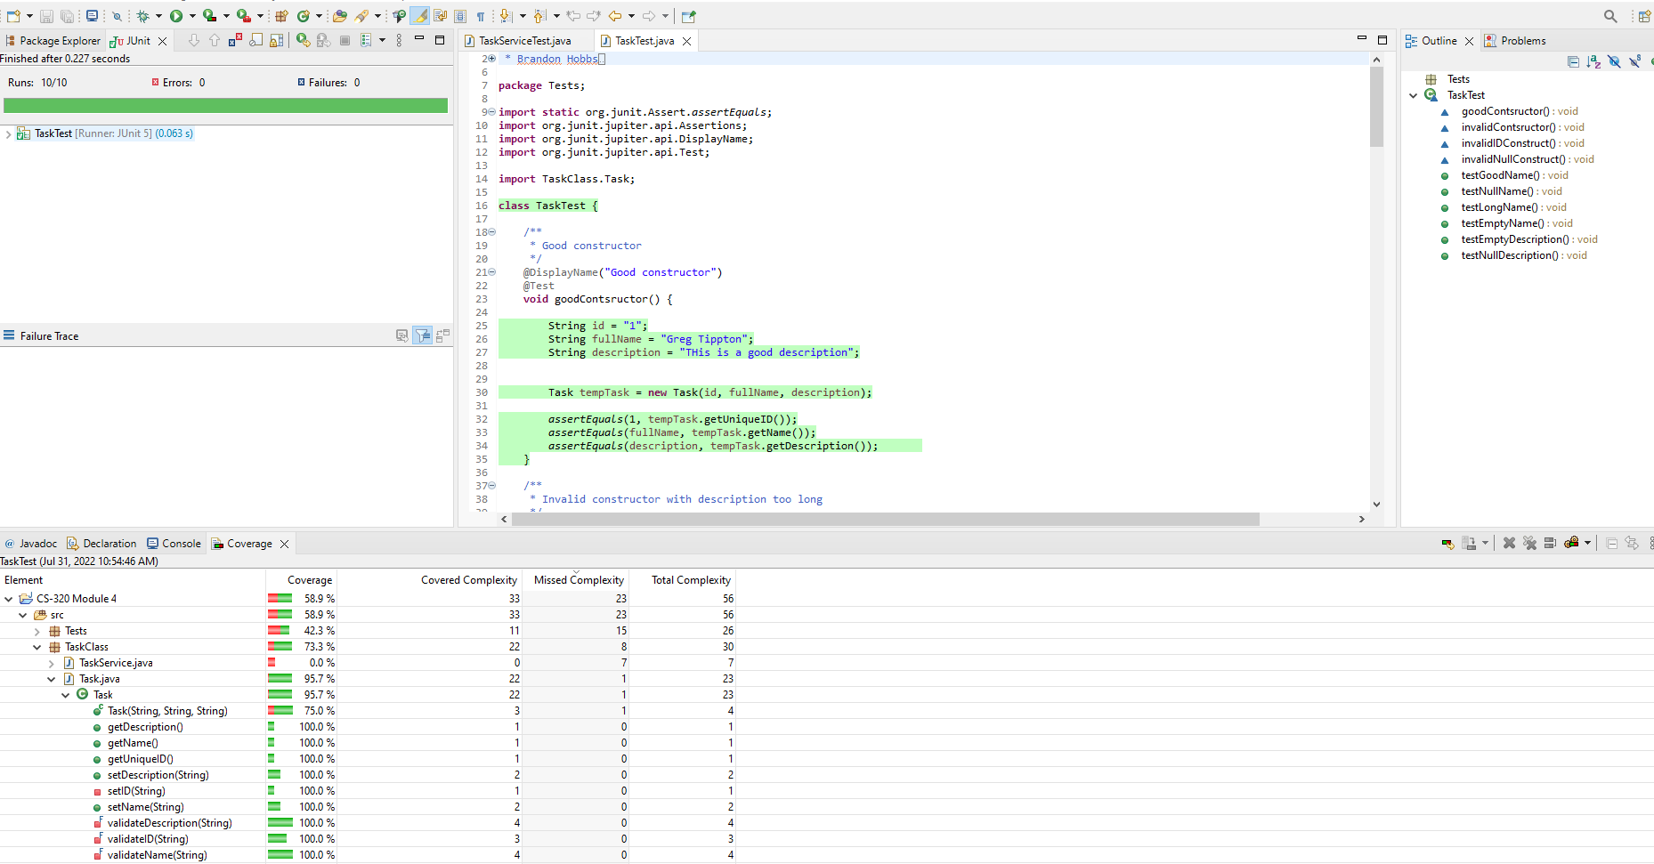

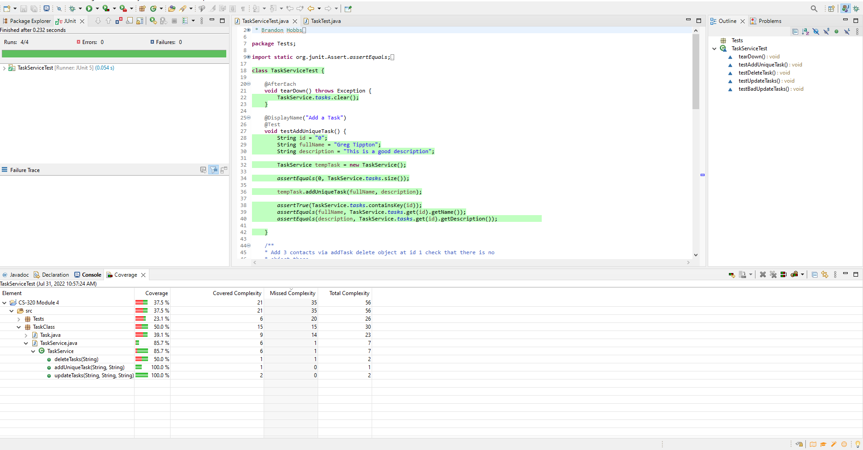

***Downloaded Code (renamed packages and classes to distinquish)***

